# To monitor preemption while setting priority we toggle 3 different pins.

RED LED:

S32_NVIC->IP[48] = 0x20; /* IRQ48-LPIT0_Ch0_IRQHandler: *LED_RED priority 2* of 0-15*/

GREEN LED:

S32_NVIC->IP[49] = 0xA0; /* IRQ49-LPIT0_Ch1_IRQHandler: *LED_GREEN priority 10* of 0-15*/

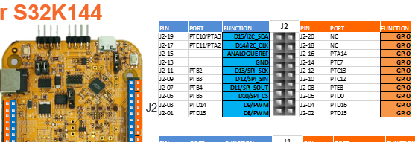

GREEN RGB

RED RGB

BLUE RGB

Red toggled by PIT0 CH0 priority number 0x20, PIT0 CH1 prioirty 0xA0. A higher number in S32_NVIC{ } ->IP means

BLUE RGB is nested in LPIT0_Ch1_IRQHandler, configured to toggle in predefined period:

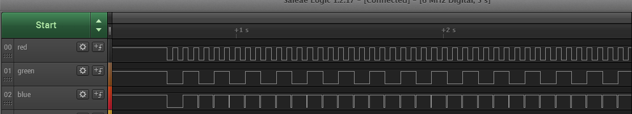

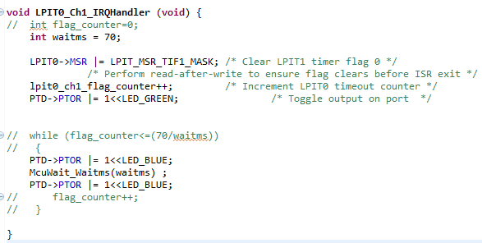

# Let´s invert the priorities:

RED LED:

S32_NVIC->IP[48] = 0xA0; /* IRQ48-LPIT0_Ch0_IRQHandler: *LED_RED priority 10* of 0-15*/

GREEN LED:

S32_NVIC->IP[49] = 0x20; /* IRQ49-LPIT0_Ch1_IRQHandler: *LED_GREEN priority 0x20* of 0-15*/

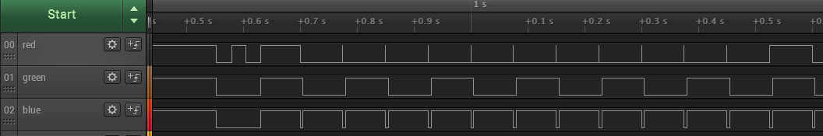

RED RGB is preempted because toggled into LPIT0_Ch0_IRQHandler with lower priority than Green task which is called to toggle BLUE RGB.

# If RED RGB is toggled in MAIN…

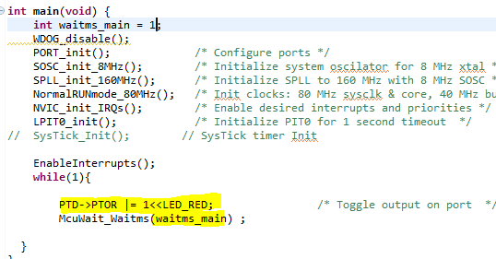

Code in main program is executed only when none of the other two interruptions is called.

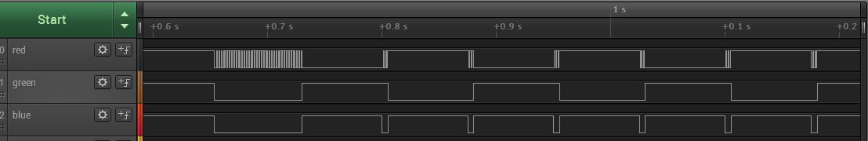

Executed with the lowest priority

# If RED RGB is toggled in Systick…

Priority 0x01 set in SHPR3

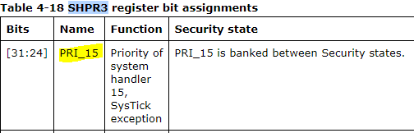

<http://infocenter.arm.com/help/index.jsp?topic=/com.arm.doc.dui0552a/CHDBIBGJ.html>

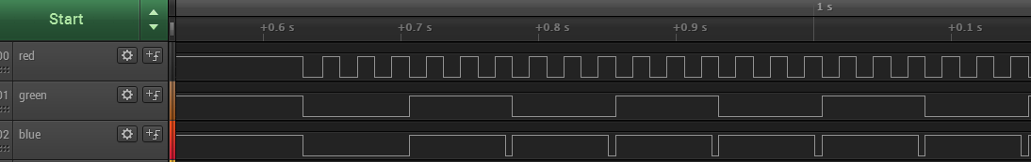

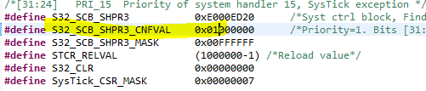

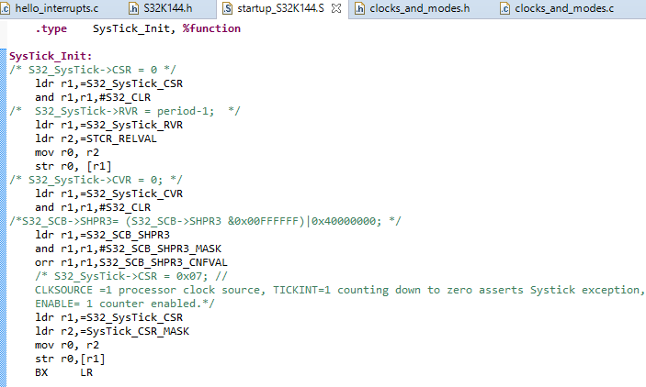

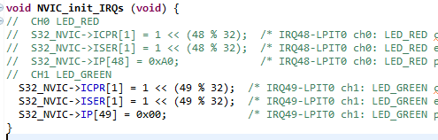

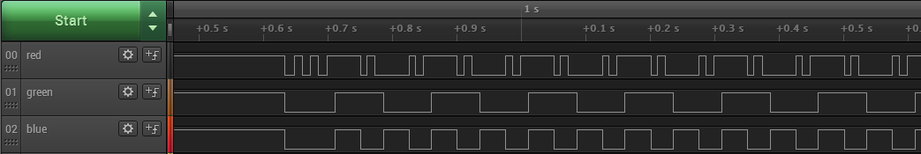

We invert the priority.

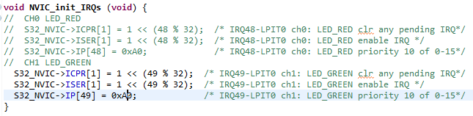

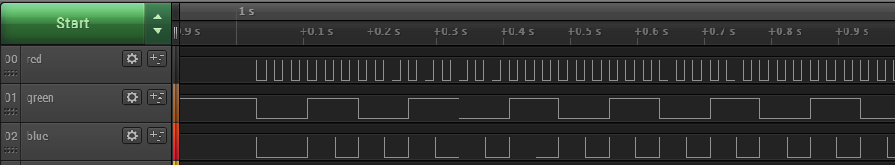

References:

[1] S32K ,Schematic diagram, <https://www.nxp.com/downloads/en/schematics/S32K144EVB-SCH-29248-RB1.pdf>